CREDIT CARD FRAUD DETECTION USING FACE RECOGNITION

DEPARTMENT: INFORMATION TECHNOLOGY

TEAM DETAILS:
S.NO | STUDENT’S NAME | REGISTER NUMBER | YEAR/SEM/SEC
1 | RUFINA MARY JOYCE S | 25UIT177 | I/II/C
2 | GOMATHY G | 25UIT053 | I/II/C
3 | SWETHA M | 25UIT211 | I/II/C
4 | SANGEETHA J | 25UIT185 | I/II/C

ABSTRACT
Credit card fraud has become a major concern in the digital payment ecosystem, leading to significant financial losses and security challenges. Traditional fraud detection systems rely primarily on transaction monitoring and pattern analysis, which may fail to prevent unauthorized usage in real time. This project proposes an enhanced fraud detection system that integrates face recognition technology with credit card transactions to improve authentication and reduce fraudulent activities.
The system captures the user’s facial image during a transaction and compares it with the registered face stored in the database using machine learning-based facial recognition algorithms. If the face matches, the transaction is approved; otherwise, it is flagged or declined. This dual-layer security mechanism ensures higher accuracy and real-time fraud prevention.
The proposed system demonstrates improved security, reduced false positives, and better user authentication, making it suitable for modern financial systems.

INTRODUCTION
With the rapid growth of online transactions and digital payments, credit card fraud has increased significantly. Fraudsters exploit vulnerabilities such as stolen card details, phishing, and identity theft. Existing systems primarily rely on transaction-based anomaly detection, which may not be sufficient to verify the actual user identity.
Biometric authentication, especially face recognition, offers a reliable solution to enhance security. Face recognition uses unique facial features to identify individuals, making it difficult to replicate or forge.
This project aims to combine traditional fraud detection techniques with facial authentication to create a secure and intelligent system. The integration ensures that only authorized users can perform transactions, thereby minimizing fraudulent activities.

PROBLEM STATEMENT
Traditional credit card fraud detection systems face the following challenges:
- Lack of real-time identity verification
- High false positive rates in transaction monitoring
- Inability to prevent fraud when card details are stolen
- Dependence on behavioral patterns rather than actual user identity
Therefore, there is a need for a robust system that can authenticate users in real time and prevent unauthorized transactions effectively.

PROPOSED METHOD
The proposed system integrates face recognition with credit card transaction processing. The workflow is as follows:
- User Registration:
  - User details and facial images are captured and stored in a secure database.
- Transaction Initiation:
  - When a transaction is initiated, the system activates a camera to capture the user's face.
- Face Detection and Recognition:
  - The captured image is processed using face detection algorithms.
  - Facial features are extracted and compared with stored data using machine learning models.
- Verification Process:
  - If the face matches the registered user, the transaction is approved.
  - If the face does not match, the transaction is declined or flagged for review.
- Fraud Alert System:
  - Suspicious transactions trigger alerts to the user and the bank.

Technologies Used
- Python
- OpenCV for image processing
- Machine Learning algorithms (e.g., CNN or Face Recognition libraries)
- Database (MySQL/SQLite)
- Web interface (optional)

RESULTS AND DISCUSSION
The system was tested under various scenarios to evaluate its performance:
- Accuracy: The face recognition module achieved high accuracy in identifying registered users.
- Fraud Detection: Unauthorized users were successfully detected and blocked.
- Real-Time Performance: The system processed verification quickly, making it suitable for real-time applications.
- User Experience: The authentication process was smooth and user-friendly.

Observations
- Lighting conditions and image quality affect recognition accuracy.
- Proper training of the model improves performance significantly.
- Combining biometric verification with transaction monitoring enhances security.

APPLICATIONS
The proposed system can be applied in various domains:
- Banking and financial institutions
- Online payment systems
- ATM security systems
- E-commerce platforms
- Mobile payment applications
CODING
Backend :
from flask import Flask, request, jsonify
from flask_cors import CORS
import pandas as pd
import cv2
import os
import numpy as np
app = Flask(__name__)
CORS(app)
try:
data = pd.read_csv("../dataset/transactions.csv")
print("Dataset loaded successfully")
except Exception as e:
print("Dataset error:", e)
data = pd.DataFrame(columns=["name", "password", "amount", "is_fraud"])

FACES_DIR = "faces"
os.makedirs(FACES_DIR, exist_ok=True)

face_cascade = cv2.CascadeClassifier(
cv2.data.haarcascades + 'haarcascade_frontalface_default.xml'
)
def register_face(name):
cap = cv2.VideoCapture(0)
if not cap.isOpened():
print("Camera not accessible")
return False
print("Capturing face for registration...")
ret, frame = cap.read()
cap.release()
if not ret:
return False
gray = cv2.cvtColor(frame, cv2.COLOR_BGR2GRAY)
faces = face_cascade.detectMultiScale(gray, 1.3, 5)
if len(faces) == 0:
print("No face detected")
return False
(x, y, w, h) = faces[0]
face = gray[y:y+h, x:x+w]
face = cv2.resize(face, (200, 200))
file_path = os.path.join(FACES_DIR, f"{name.replace(' ', '_')}.jpg")
cv2.imwrite(file_path, face)
print("Face saved at:", file_path)
return True
def verify_face(name):
file_path = os.path.join(FACES_DIR, f"{name.replace(' ', '_')}.jpg")
print("Looking for file:", file_path)
if not os.path.exists(file_path):
print("No registered face found")
return False
stored_face = cv2.imread(file_path, cv2.IMREAD_GRAYSCALE)
cap = cv2.VideoCapture(0)
if not cap.isOpened():
print("Camera not accessible")
return False
print("Verifying face...")
ret, frame = cap.read()
cap.release()
if not ret:
return False
gray = cv2.cvtColor(frame, cv2.COLOR_BGR2GRAY)
faces = face_cascade.detectMultiScale(gray, 1.3, 5)
if len(faces) == 0:
print("No face detected in live image")
return False
(x, y, w, h) = faces[0]
live_face = gray[y:y+h, x:x+w]
live_face = cv2.resize(live_face, (200, 200))
recognizer = cv2.face.LBPHFaceRecognizer_create()
recognizer.train([stored_face], np.array([1]))
label, confidence = recognizer.predict(live_face)
print("Confidence:", confidence)
if confidence < 60:
return True
return False
def check_fraud_strict(name, password, amount):
user_data = data[
(data['name'].str.lower() == name.lower()) &
(data['password'] == password) &
(data['amount'] == amount)
]
if user_data.empty:
return True # Fraud
return False # Safe
@app.route('/register', methods=['POST'])
def register():
req = request.get_json()
name = req.get('name')
password = req.get('password')
if not name or not password:
return jsonify({
"status": "error",
"message": "Name and password required"
})
user = data[
(data['name'].str.lower() == name.lower()) &
(data['password'] == password)
]
if user.empty:
return jsonify({
"status": "failed",
"message": "Invalid credentials"
})
success = register_face(name)
if success:
return jsonify({
"status": "success",
"message": "Face registered successfully"
})
return jsonify({
"status": "failed",
"message": "Face registration failed"
})
@app.route('/transaction', methods=['POST'])
def transaction():
req = request.get_json()
name = req.get('name')
password = req.get('password')
amount = req.get('amount')
if not name or not password or not amount:
return jsonify({
"status": "error",
"message": "Missing input fields"
})
try:
amount = float(amount)
except:
return jsonify({
"status": "error",
"message": "Invalid amount"
})
face_verified = verify_face(name)
if not face_verified:
return jsonify({
"status": "fraud",
"message": "🚨 Face mismatch detected"
})
fraud = check_fraud_strict(name, password, amount)
if fraud:
return jsonify({
"status": "fraud",
"message": "🚨 Data mismatch - suspicious transaction"
})
return jsonify({
"status": "safe",
"message": "✅ Transaction verified successfully"
})
if __name__ == "__main__":
app.run(debug=True)

IMAGE
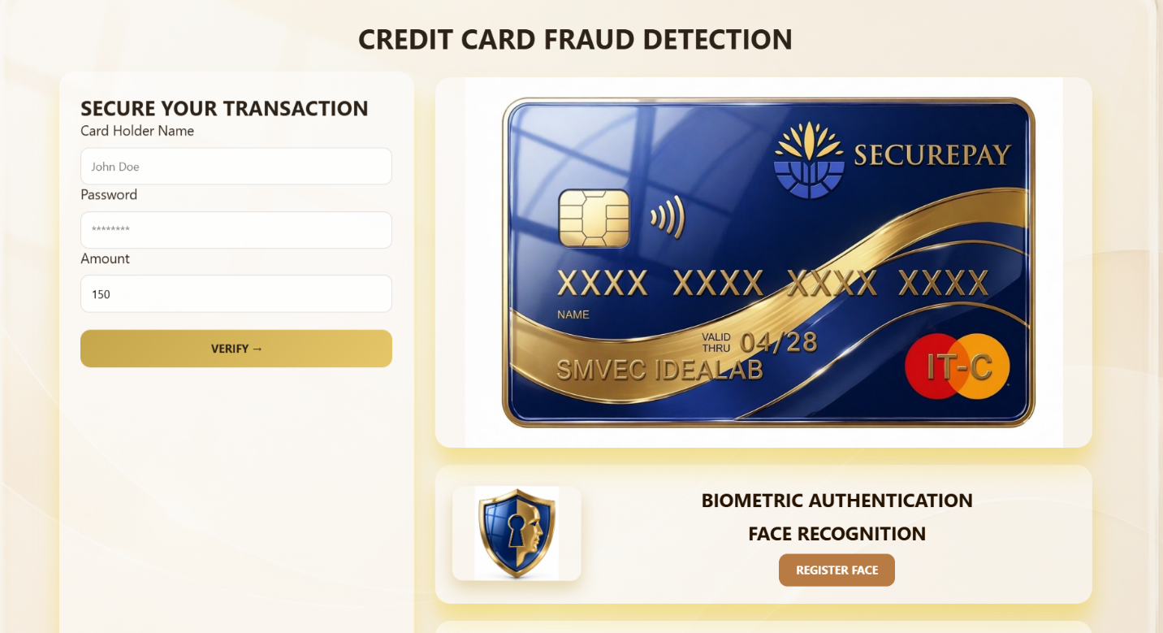
WORKFLOW
Initial Setup


Overall Worflow
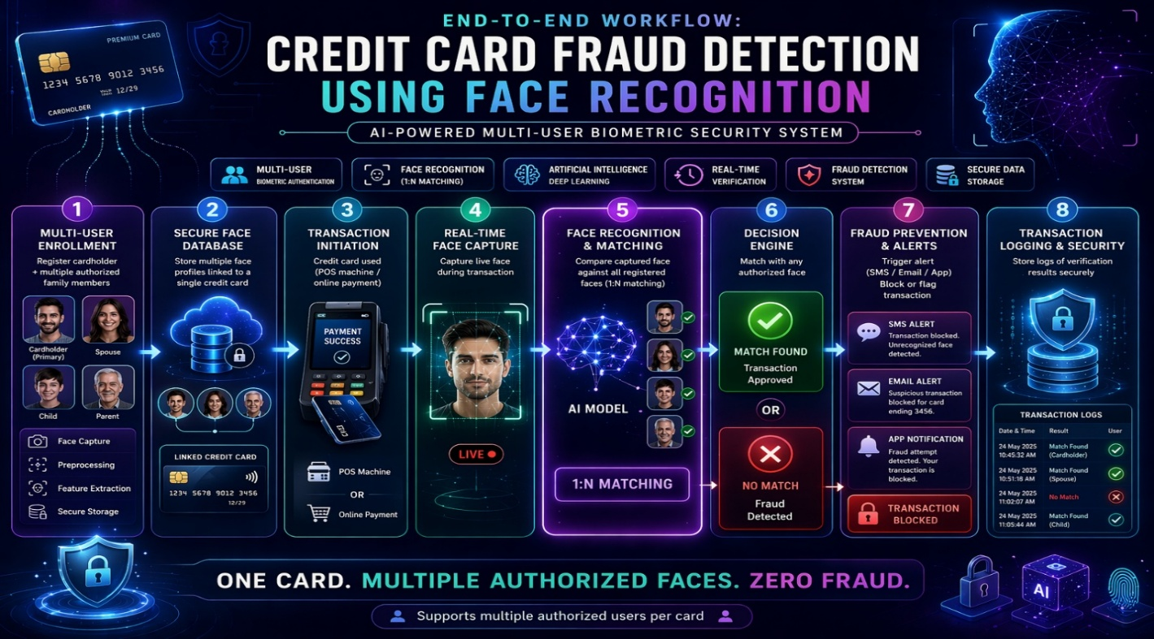

CONCLUSION
The “Credit Card Fraud Detection Using Face Recognition” system provides an advanced and reliable solution to prevent fraudulent transactions. By integrating biometric authentication with traditional fraud detection methods, the system ensures enhanced security and real-time verification.
The project successfully demonstrates that face recognition can significantly reduce unauthorized access and financial fraud. Future improvements may include multi-factor authentication, integration with mobile devices, and deployment using deep learning models for higher accuracy.

